MOTHERBOARD AND CPU

- Understanding Motherboards, CPU, Sockets, and System Components

- INTRODUCTION:

A motherboard is the main circuit board of a computer and serves as the foundation of the entire system. It connects all major hardware components, including the CPU, RAM, storage devices, graphics card, and power supply, allowing them to communicate with each other. Without a motherboard, the computer cannot function because all components depend on it for data transfer and power distribution.

Understanding the motherboard and CPU is essential for anyone interested in computer hardware, system building, gaming, or cybersecurity. A good knowledge of these components helps in selecting compatible hardware, upgrading a computer, and troubleshooting hardware-related problems.

- WHAT IS A MOTHERBOARD?

A motherboard is the primary printed circuit board (PCB) inside a computer. It acts as the central communication hub that connects and controls all hardware components. Every component, such as the processor, memory, storage devices, graphics card, cooling system, and peripheral devices, is connected either directly or indirectly to the motherboard.

Modern motherboards include different slots, connectors, and ports that allow users to install and upgrade computer hardware according to their needs.

- MAIN COMPONENTS OF A MOTHERBOARD

COMPONENTS | FUNCTION
1. CPU Socket | Holds and connects the processor.
2. RAM Slots | Install memory modules.
3. PCle x Slot | Used for a graphics card.
4. PCle x1 Slot | Used for expansion cards like Wi-Fi or sound cards.
5. SATA Ports | Connect HDDs and SATA SSDs.
6. M.2 Slot | Connect NVME SSDs for high-speed storage.
7. (24-Pin Power Connector) | Supplies power to the motherboard.
8. CPU power Connector | Provides power to the processor.
9. CMOS Battery | Storage BIOS settings and system time.
10. Rear I/O Ports | Connect USB devices, monitor, keyboard, mouse, LAN, and audio.

- TYPES OF MOTHERBOARDS

- ATX - Advanced Technology Extended.
- Micro – ATX (MATX) - Micro Advanced Technology Extended.
- Mini-ITX – Mini Information Technology Extended.
- E – ATX – Extended ATX.
- XL- ATX – Extra Large ATX.
- Flex – ATX – Flexible ATX.

- CONCLUSION:
Motherboards are available in different types to meet different user requirements. ATX is the most popular choice for gaming and high-performance computers because it offers more expansion slots and better upgrade options. Micro-ATX is suitable for home and office users who need a balance between performance and cost, while Mini-ITX is ideal for compact and space-saving systems. E-ATX and XL-ATX are designed for professional workstations and enthusiast gaming PCs, whereas Flex-ATX is mainly used for budget and basic desktop computers. Choosing the right motherboard depends on the user's needs, budget, computer size, and future upgrade plans. A suitable motherboard ensures better compatibility, stable performance, and a longer system lifespan.

- LABELED DIAGRAM OF AN ATX MOTHERBOARD

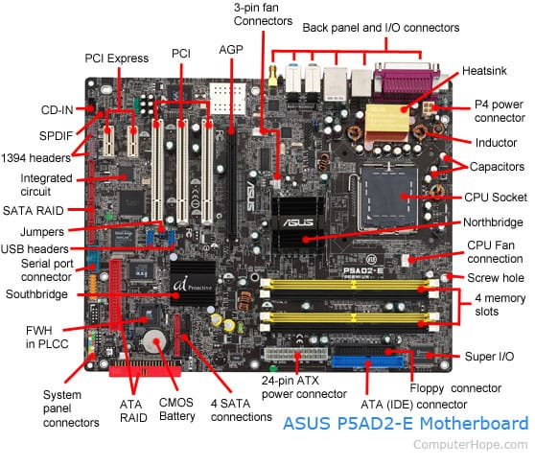

- POPULAR CPU SOCKET TYPES AND COMPATIBLE PROCESSORS

- INTRODUCTION:

A CPU socket is a connector on the motherboard that holds the processor (CPU) and allows it to communicate with other hardware components. Different processors require different socket types, so the CPU and motherboard must be compatible. Choosing the correct socket ensures proper installation, stable performance, and future upgrade options.

- OLDER CPU SOCKET TYPES

These sockets were widely used in older computers but are now discontinued.
Socket Type | Compatible CPU | Description
- Socket 370 | Intel Pentium lll | Used in older desktop computers during the late 1990s and early 2000s.
- LGA 775 (Socket T) | Intel Core 2 Duo | One of intel’s most popular older sockets, supporting Pentium 4 , Core 2, Duo , and Core 2 Quad processors.
- AM2/ AM3 | AMD Athlon 64, AMD Phenom ll | Older AMD sockets that supported DDR2 and DDR3 memory.

- POPULAR CPU SOCKET TYPES (CURRENT GENERATION)

These sockets are still widely used in modern desktop computers.
SOCKET TYPE | COMPATIBLE CPU | MANUFACTURER | DESCRIPTION
LGA 1700 | Intel Core i5-12400,i7-14700K | Intel | Supports Intel 12th, 13th, and 14th, Generation processors with DDR4 or DDR5 memory.
AM4 | AMD Ryzen 5 5600X | AMD | One of AMD’s most successful sockets, supporting a wide range of Ryzen processors with DDR4 memory.
AM5 | AMD Ryzen 7 7700X | AMD | AMD’s latest socket designed for ryzen 7000 and newer processors with DDR5 memory and PCle 5.0 support.

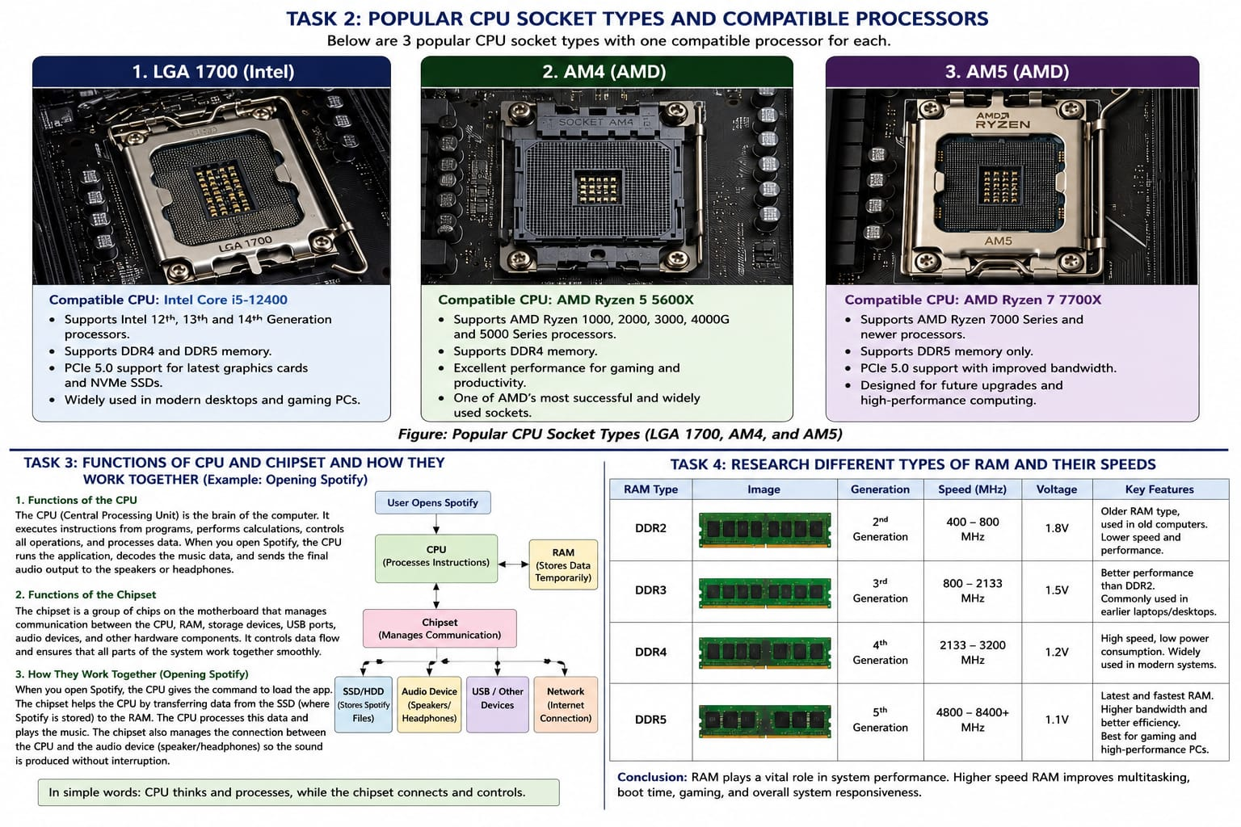

- HIGH – END AND WORKSTATION CPU SOCKETS

These sockets are designed for professional workstations and servers.

SOCKET TYPE | COMPATIBLE CPU | USED FOR
LGA 4677 | Intel Xeon Scalable Processors | Servers, Data Centers, AI Workstations.
STR5 | AMD RyzenThreadripper PRO 7000 Series | Professional Workstations, 3D Rendering, Engineering.
SP5 | AMD EPYC Series | Enterprise Servers and Cloud Computing.

- COMPARISON OF MODERN CPU SOCKETS

SOCKET | MEMORY SUPPORT | BEST USE
LGA 1700 | DDR4/DDR5 | Gaming, Programming, Productivity.
AM4 | DDR4 | Budget Gaming, Home and office PCs.
AM5 | DDR5 | High-End Gaming, Future Upgrades, Content Creation.

- WHY CPU SOCKET COMPATIBILITY IS IMPORTANT?

The CPU socket determines whether a processor can be installed on a motherboard. If the socket type does not match, the processor will not fit or work. Before buying a processor or motherboard, users should always verify socket compatibility to ensure stable performance and avoid hardware incompatibility. Choosing the correct socket also makes future upgrades easier.

- CONCLUSION:

The CPU socket determines whether a processor can be installed on a motherboard. If the socket type does not match, the processor will not fit or work. Before buying a processor or motherboard, users should always verify socket compatibility to ensure stable performance and avoid hardware incompatibility. Choosing the correct socket also makes future upgrades easier.

- FUNCTIONS OF THE CPU AND CHIPEST ON A MOTHERBOARD

- INTRODUCTION:

The CPU (Central Processing Unit) and the chipset are two important components of a motherboard. The CPU performs calculations and executes instructions, while the chipset controls communication between the CPU and other hardware components such as RAM, storage devices, USB ports, and audio devices. Both work together to ensure the computer runs smoothly and efficiently.

- FUNCTIONS OF THE CPU

The CPU is called the brain of the computers because it processes all instructions given by software and hardware.

- MAIN FUNCTIONS OF THE CPU:

- Executes program instructions.
- Performs user input from the keyboard and mouse.
- Controls multitasking.
- Performs calculations and logical operations.
- Manages applications such as web browsers, games, and music players.
- Coordinates with RAM and storage to load data quickly.

- FUNCTIONS OF THE CHIPEST

The chipset is a group of controller chips on the motherboard that manages communication between the CPU and other hardware components.

- MAIN FUNCTIONS OF CHIPEST

- Connects the CPU with RAM, SSD, HDD, GPU, and USB devices.
- Controls data transfer between hardware components.
- Manages SATA, PCle, USB, and audio ports.
- Supports networking and storage controllers.
- Ensures all motherboard components work together properly.

- HOW THE CPU AND CHIPSET WORK TOGETHER (EXAMPLE: OPENING SPOTIFY)

When you open Spotify, the CPU receives your command and starts executing the application. The chipset helps the CPU access the program files stored on the SSD, loads the required data into RAM, and manages communication with the speakers or headphones. The CPU processes the music playback while the chipset handles data transfer between the storage, memory, audio device, and other motherboard components, allowing smooth and uninterrupted music playback.

- CONCLUSION:

The CPU and chipset work together to make the computer function efficiently. The CPU performs the actual processing, while the chipset manages communication between different hardware components. Without proper coordination between these two components, applications such as Spotify, games, and web browsers would not run smoothly.

Keyboard/Mouse
│
▼
CPU
│
▼
Chipset
┌────┼─────┐
▼ ▼ ▼
RAM / SSD USB/Audio

- IDENTIFICATION OF MOTHERBOARD PORTS AND SLOTS

- INTRODUCTION:

A motherboard contains different ports and slots that connect all the hardware components of a computer. Each port or slot has a specific function, such as connecting the processor, memory, storage devices, graphics card, and power supply. Understanding these components helps in assembling, upgrading, and troubleshooting a computer.

- DIAGRAM OF MOTHERBOARD

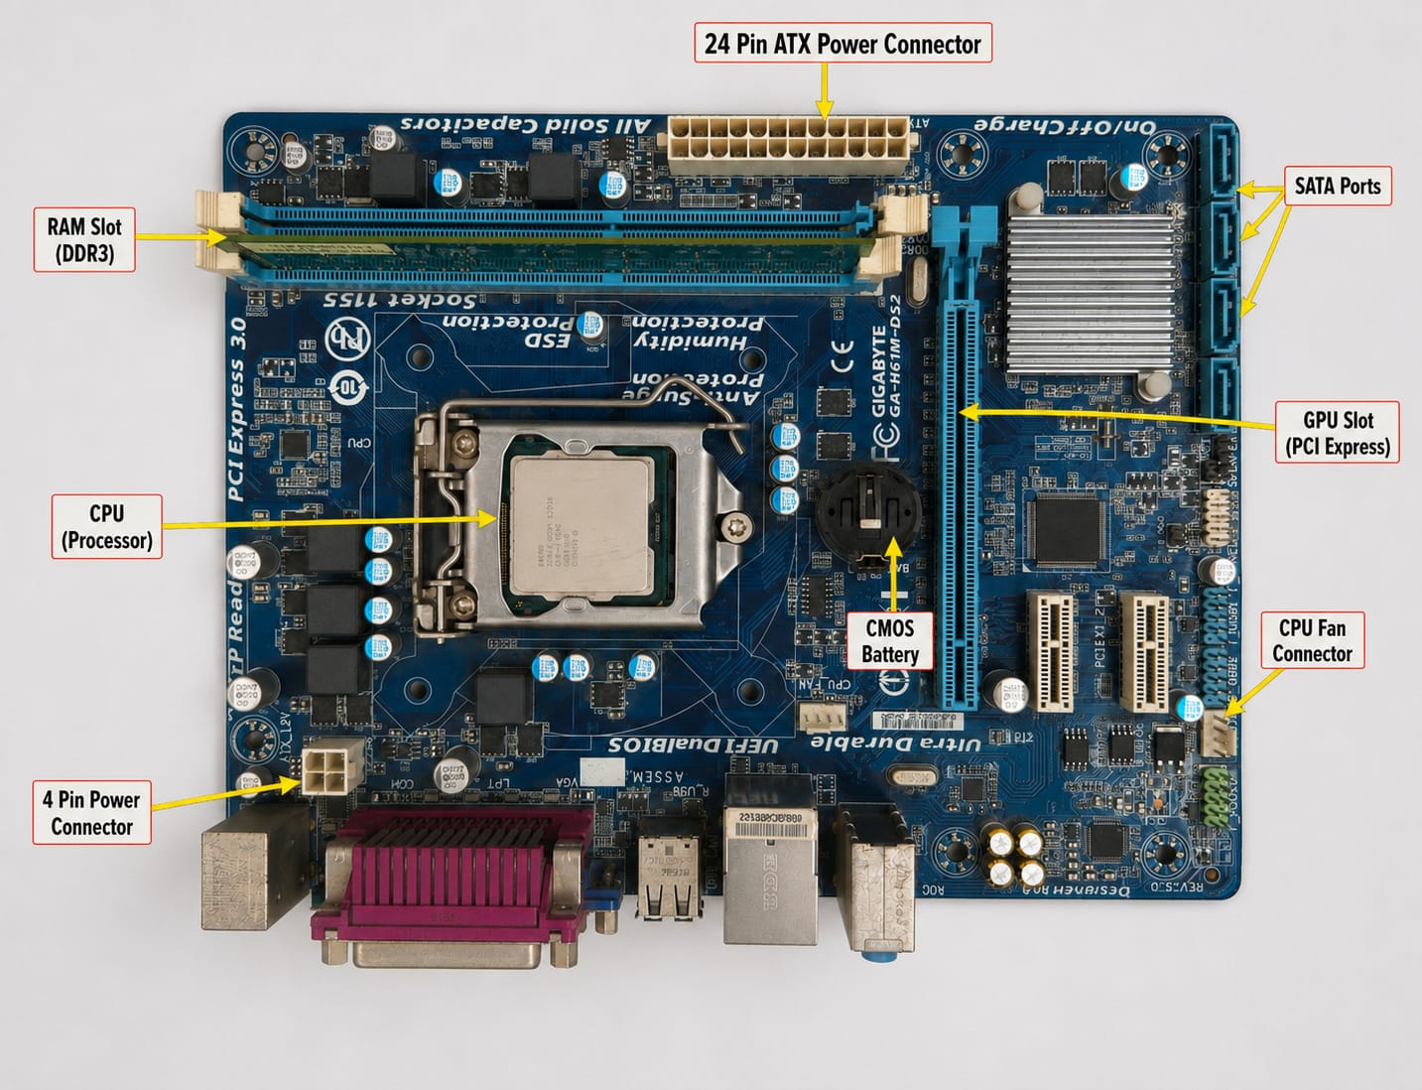

- LIST OF MOTHERBOARDS PARTS

- CPU Socket – Holds the processor (CPU) and allows it to communicate with the motherboard.
- RAM Slots (DIMM) – Used to install memory modules (DDR4/DDR5 RAM).
- 3. PCIe x16 Slot – Used for installing a dedicated graphics card (GPU).
- M.2 Slot – Used for installing high-speed NVMe SSDs.
- SATA Ports – Connect SATA HDDs and SSDs.
- 24-Pin ATX Power Connector – Supplies the main power to the motherboard.
- 8-Pin CPU Power Connector (EPS) – Provides dedicated power to the processor.
- Rear I/O Ports – Includes USB, HDMI/DisplayPort, Ethernet, audio ports, and other external connections.
- CMOS Battery – Stores BIOS/UEFI settings and maintains the system clock.
- Chipset (PCH) – Controls communication between the CPU, storage, USB ports, and other motherboard components.

- CONCLUSION:

The motherboard is the backbone of a computer because it connects and manages all hardware components. Learning about its ports and slots helps users assemble, upgrade, troubleshoot, and maintain a computer efficiently. Understanding these components is an essential skill for every IT student.

